**Ramrao Adik Institute of Technology**

## (Department of Computer Engineering)



**Mini Project Report**

# On

## Employee Payment Management System

**Subject-: Open Source Technology Lab**

***Presented By***

Roll No Batch-Sr. No Name

**17CE8017 *C1 – 5 MEENAL CHAVAN***

**17CE7022**

***C1 – 13***

***ANIKET KAMBLE***

**17CE7013**

**17CE8001**

***C1 – 7***

***C1 - 14***

***Under the guidance of***

**Mr.Vishwanath Chikkareddi**

***SHUBHAM DASPUTE***

***AKSHAY SAHU***

**Signature of Internal Examiner Signature of External Examiner**

**Contents of Report**

**Index**

|  |  |  |
| --- | --- | --- |
| **Sr.No.** | **Contents** | **Page No.** |
| 1. | Abstract | 3 |
| 2. | Introduction | 3 |
| 3. | Implementation | 4 |
| 4. | Screenshots | 11 |
| 5. | Conclusion | 12 |

**Abstract**

The project “Employee Payment Management System” is implemented to reduce the manual work and enhances the accuracy of work in any office or workplace.

This project is also designed with full consideration to help the users in an easy manner without any unnecessary wastage of time. This system can be implemented in big office where managers can keep a track of wages of employees using system. The messaging system tells the manager to supply the particular amount to particular employee. The payment system prepares the pay slip according to the working hours of a particular employee. This system entirely reduces the unnecessary wastage of time and energy.

## Chapter 1-Introduction

*Existing System*

* The system is manual processing for managing the payment of employees.
* Lot of paper work so that the data processing is very slow and we know after one month how much payment is to be done for each employee.

*Need For New System*

* Registered user can have immediate access to their daily as well as monthly wages.
* *Registered user can easily list out their daily payment without actually calculating the salary physically.
* To manage all the payments as well as overtime in database and after a month system generate payslip then we know how much payment is to be done for each employee.
* *Managers can get the notification message via Email of overtime as well.

## Chapter-2 Implementation

import time import datetime

from tkinter import * import tkinter.messagebox root=Tk()

root.title("Employee payroll system") root.geometry('1350x650+0+0') root.configure(background="powder blue") Tops=Frame(root,width=1350,height=50,bd=8,bg="powder blue") Tops.pack(side=TOP) f1=Frame(root,width=600,height=600,bd=8,bg="powder blue") f1.pack(side=LEFT) f2=Frame(root,width=300,height=700,bd=8,bg="powder blue") f2.pack(side=RIGHT) fla=Frame(f1,width=600,height=200,bd=8,bg="powder blue") fla.pack(side=TOP) flb=Frame(f1,width=300,height=600,bd=8,bg="powder blue") flb.pack(side=TOP)

lblinfo=Label(Tops,font=('arial',45,'bold'),text="Employee Payment Management system ",bd=10,fg="green")

lblinfo.grid(row=0,column=0) def exit():

exit=tkinter.messagebox.askyesno("Employee system","Do you want to exit the system")

if exit>0: root.destroy() return

def reset(): Name.set("")

Address.set("") HoursWorked.set("") wageshour.set("") Payable.set("")

Taxable.set("") NetPayable.set("") GrossPayable.set("") OverTimeBonus.set("") Employer.set("")

NINumber.set("") txtpayslip.delete("1.0",END) def enterinfo(): txtpayslip.delete("1.0",END)

txtpayslip.insert(END,"\t\tPay Slip\n\n") txtpayslip.insert(END,"Name :\t\t"+Name.get()+"\n\n") txtpayslip.insert(END,"Address :\t\t"+Address.get()+"\n\n") txtpayslip.insert(END,"Employer :\t\t"+Employer.get()+"\n\n")

txtpayslip.insert(END,"NI Number :\t\t"+NINumber.get()+"\n\n") txtpayslip.insert(END,"Hours Worked :\t\t"+HoursWorked.get()+"\n\n") txtpayslip.insert(END,"Net Payable :\t\t"+NetPayable.get()+"\n\n") txtpayslip.insert(END,"Wages per hour :\t\t"+wageshour.get()+"\n\n") txtpayslip.insert(END,"Tax Paid :\t\t"+Taxable.get()+"\n\n") txtpayslip.insert(END,"Payable :\t\t"+Payable.get()+"\n\n")

def weeklywages(): txtpayslip.delete("1.0",END)

hoursworkedperweek=float(HoursWorked.get()) wagesperhours=float(wageshour.get()) paydue=wagesperhours*hoursworkedperweek paymentdue="INR",str('%.2f'%(paydue)) Payable.set(paymentdue)

tax=paydue*0.2 taxable="INR",str('%.2f'%(tax)) Taxable.set(taxable) netpay=paydue-tax

netpays="INR",str('%.2f'%(netpay)) NetPayable.set(netpays)

if hoursworkedperweek > 40: overtimehours=(hoursworkedperweek-40)+wagesperhours*1.5 overtime="INR",str('%.2f'%(overtimehours)) OverTimeBonus.set(overtime)

elif hoursworkedperweek<=40: overtimepay=(hoursworkedperweek-40)+wagesperhours*1.5 overtimehrs="INR",str('%.2f'%(overtimepay)) OverTimeBonus.set(overtimehrs)

return

# Variables Name=StringVar() Address=StringVar() HoursWorked=StringVar() wageshour=StringVar() Payable=StringVar() Taxable=StringVar() NetPayable=StringVar() GrossPayable=StringVar() OverTimeBonus=StringVar() Employer=StringVar() NINumber=StringVar() TimeOfOrder=StringVar() DateOfOrder=StringVar()

DateOfOrder.set(time.strftime("%d/%m/%Y"))

# Label Widget

lblName=Label(fla,text="Name",font=('arial',16,'bold'),bd=20,fg="red",bg="powd er blue").grid(row=0,column=0)

lblAddress=Label(fla,text="Address",font=('arial',16,'bold'),bd=20,fg="red",bg="p owder blue").grid(row=0,column=2)

lblEmployer=Label(fla,text="Employer",font=('arial',16,'bold'),bd=20,fg="red",bg

="powder blue").grid(row=1,column=0)

lblNINumber=Label(fla,text="NI Number",font=('arial',16,'bold'),bd=20,fg="red",bg="powder blue").grid(row=1,column=2)

lblHoursWorked=Label(fla,text="Hours Worked",font=('arial',16,'bold'),bd=20,fg="red",bg="powder blue").grid(row=2,column=0)

lblHourlyRate=Label(fla,text="Hourly Rate",font=('arial',16,'bold'),bd=20,fg="red",bg="powder blue").grid(row=2,column=2)

lblTax=Label(fla,text="Tax",font=('arial',16,'bold'),bd=20,anchor='w',fg="red",bg= "powder blue").grid(row=3,column=0)

lblOverTime=Label(fla,text="OverTime",font=('arial',16,'bold'),bd=20,fg="red",bg

="powder blue").grid(row=3,column=2)

lblGrossPay=Label(fla,text="GrossPay",font=('arial',16,'bold'),bd=20,fg="red",bg= "powder blue").grid(row=4,column=0)

lblNetPay=Label(fla,text="Net Pay",font=('arial',16,'bold'),bd=20,fg="red",bg="powder blue").grid(row=4,column=2)

#Entry Widget

etxname=Entry(fla,textvariable=Name,font=('arial',16,'bold'),bd=16,width=22,justi fy='left')

etxname.grid(row=0,column=1)

etxaddress=Entry(fla,textvariable=Address,font=('arial',16,'bold'),bd=16,width=22, justify='left')

etxaddress.grid(row=0,column=3)

etxemployer=Entry(fla,textvariable=Employer,font=('arial',16,'bold'),bd=16,width= 22,justify='left')

etxemployer.grid(row=1,column=1)

etxhoursworked=Entry(fla,textvariable=HoursWorked,font=('arial',16,'bold'),bd=1 6,width=22,justify='left')

etxhoursworked.grid(row=2,column=1)

etxwagesperhours=Entry(fla,textvariable=wageshour,font=('arial',16,'bold'),bd=16, width=22,justify='left')

etxwagesperhours.grid(row=2,column=3)

etxnin=Entry(fla,textvariable=NINumber,font=('arial',16,'bold'),bd=16,width=22,ju stify='left')

etxnin.grid(row=1,column=3)

etxgrosspay=Entry(fla,textvariable=Payable,font=('arial',16,'bold'),bd=16,width=22

,justify='left') etxgrosspay.grid(row=4,column=1)

etxnetpay=Entry(fla,textvariable=NetPayable,font=('arial',16,'bold'),bd=16,width= 22,justify='left')

etxnetpay.grid(row=4,column=3)

etxtax=Entry(fla,textvariable=Taxable,font=('arial',16,'bold'),bd=16,width=22,justi fy='left')

etxtax.grid(row=3,column=1)

etxovertime=Entry(fla,textvariable=OverTimeBonus,font=('arial',16,'bold'),bd=16, width=22,justify='left')

etxovertime.grid(row=3,column=3)

# Text Widget payslip=Label(f2,textvariable=DateOfOrder,font=('arial',21,'bold'),fg="red",bg="p owder blue").grid(row=0,column=0)

txtpayslip=Text(f2,height=22,width=34,bd=16,font=('arial',13,'bold'),fg="green",b g="powder blue")

txtpayslip.grid(row=1,column=0)

# buttons btnsalary=Button(flb,text='Weekly

Salary',padx=16,pady=16,bd=8,font=('arial',16,'bold'),width=14,fg="red",bg="pow der blue",command=weeklywages).grid(row=0,column=0)

btnreset=Button(flb,text='Reset',padx=16,pady=16,bd=8,font=('arial',16,'bold'),wid th=14,command=reset,fg="red",bg="powder blue").grid(row=0,column=1)

btnpayslip=Button(flb,text='View Payslip',padx=16,pady=16,bd=8,font=('arial',16,'bold'),width=14,command=enteri nfo,fg="red",bg="powder blue").grid(row=0,column=2)

btnexit=Button(flb,text='Exit System',padx=16,pady=16,bd=8,font=('arial',16,'bold'),width=14,command=exit,fg

="red",bg="powder blue").grid(row=0,column=3) root.mainloop()

## Chapter-3 Screenshots

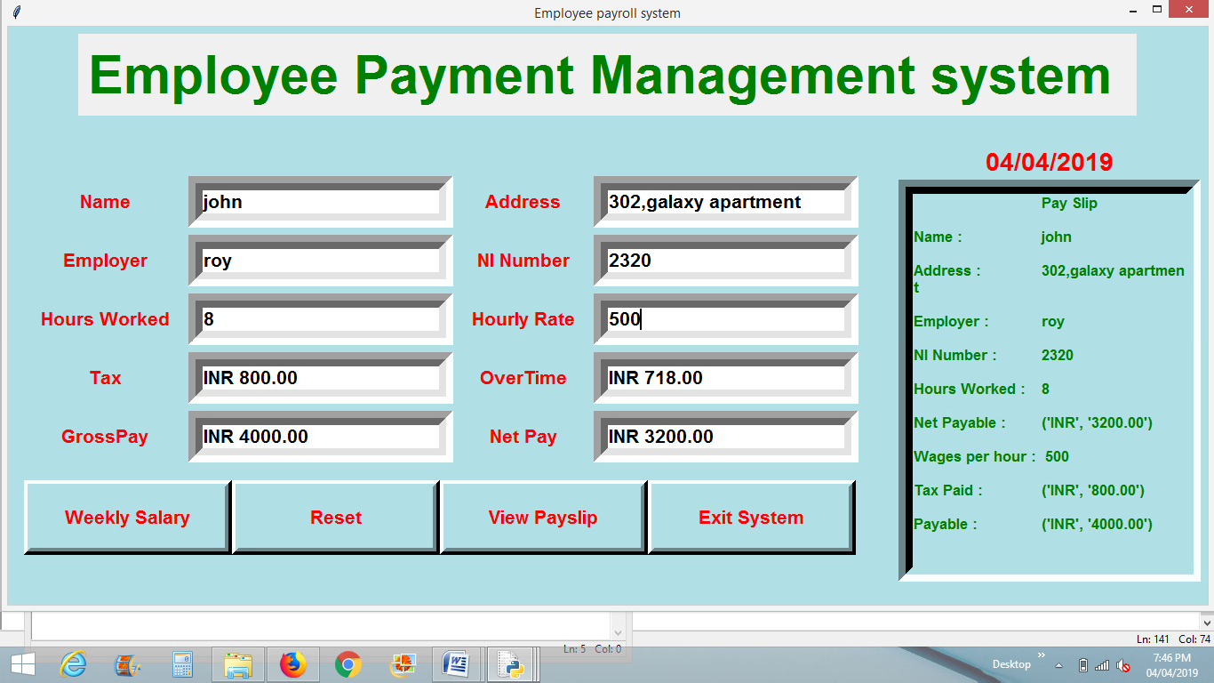

**Chapter-4 Conclusion**

Systems like Employee Payment Management aims to calculate the total pay of the payment of a particular employee. It also calculates the tax and reduces the same from the net total. It also displays the pay slip of the employee indicating the net total tax and the final salary. We learnt the various features of python which include Graphical User Interface ( GUI ) and also the concepts of classes and objects.